2021
Gert Gerber
[Company name]
10/1/2021
Flexget Installation on Linux Mint

Contents
1 Installation Of Linux Mint 4
1.1 Linux Installation 5
1.1.1 Installation 5
1.2 Tools installation 6
1.2.1 Install Guest Additions 6
1.2.2 Update Mint/Ubuntu 6
1.3 Configuration of Linux 7
1.3.1 Mount shared drive 7
2 Software installation 9
2.1 Install Sublime 10
2.1.1 Install the GPG key: 10
2.1.2 Ensure apt is set up to work with https sources: 10
2.1.3 Update apt sources and install Sublime Text 10
2.2 Install PIP3 11
2.2.1 Pip 11
2.2.2 Examples 11
2.2.3 Cloudflare 11
2.2.4 Testresources 11
2.2.5 Install Libtorrent 11
2.2.6 Future 11
2.3 SQLite Browser 12
2.4 Cloudscraper 13
2.5 Subliminal 14
2.5.1 Install from Snap Store 14
2.6 Git & Github installation 16
2.6.1 Install GIT 16
2.6.2 GITHUB 16
2.6.3 Screenshots [ Github Desktop running on Linux Mint ] 17
2.7 Flexget 19
2.7.1 Install Flexget 19
2.7.2 Flexget Scheduler 19
2.8 Transmission 21
2.8.1 Add repository 21
2.8.2 Install Transmission 21
2.8.3 Transmission-RPC 21
2.8.4 Transmission-deamon 22
2.8.5 Launch and Use Transmission 22
2.8.6 Configure deamon 24
2.8.7 Username and Password 25
2.8.8 Bash Aliases 26
2.8.9 Web Interface 27
2.8.10 Edit 27
2.9 Deluge 28
2.9.1 Install Deluge 28
2.9.2 Deluge Service 28
2.9.3 Restart the Web UI. 32
2.9.4 Thin Client 34
2.9.5 Client Setup 36
2.9.6 Deluge [Plugin] Auto Remove Plus v0.6.1 39
3 Index 49

Installation Of Linux Mint

Linux Installation

Installation
Under Construction

Tools installation

Install Guest Additions
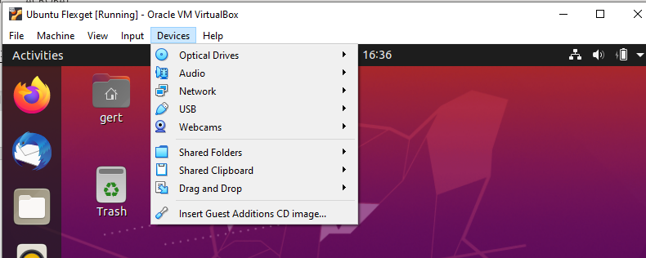

Update Mint/Ubuntu
sudo apt update && sudo apt upgrade -y

Configuration of Linux

Mount shared drive

Setup shared drive in VirtualBox
- Open VirtualBox
- Right-click your VM, then click Settings
- Go to Shared Folders section
- Add a new shared folder
- On Add Share prompt, select the Folder Path in your host that you want to be accessible inside your VM.
- In the Folder Name field, type shared
- Uncheck Read-only and Auto-mount, and check Make Permanent
- Start your VM
- Once your VM is up and running, go to Device’s menu -> Insert Guest Additions CD image menu
- Use the following command to mount the CD:
sudo mount /dev/cdrom /media/cdrom
- Install dependencies for VirtualBox guest additions:
sudo apt-get update
sudo apt-get install build-essential linux-headers-`uname -r`
- Run installation script for the guest additions:
sudo /media/cdrom/./VBoxLinuxAdditions.run
- Reboot VM
sudo shutdown -r now

Setup in Linux Machine
- Create "shared" directory in your home
mkdir ~/shared
- Mount the shared folder from the host to your ~/shared directory
sudo mount -t vboxsf shared ~/shared
- The host folder should now be accessible inside the VM.
cd ~/shared

Make the mount folder persistent
This directory mount we just made is temporary and it will disappear on next reboot. To make this permanent, we'll set it so that it will mount our ~/shared directory on system start-up
- Edit fstab file in /etc directory
sudo nano /etc/fstab
- Add the following line to fstab (separated by tabs) and press Ctrl+O to Save.
shared /home/gert/shared vboxsf defaults 0 0
- Edit modules
sudo nano /etc/modules
- Add the following line to /etc/modules and save
vboxsf
- Reboot the vm and log-in again
shutdown -r now
- Go to your home directory and check to see if the file is highlighted in green.
cd ~
ls
If it is then congratulations! You successfully linked the directory within your vm with your host folder.

Map network drive
- Edit fstab file in /etc directory
sudo nano /etc/fstab
- Add the following line to fstab (separated by tabs) and press Ctrl+O to Save.
//192.168.20.4./5gig /home/gert/gig cifs username=Gert,password=Fluffy@1215,noperm,dir_mode=0777,file_mode=0777,iocharset=utf8,_netdev 0 0
- Reboot the vm and log-in again
shutdown -r now

Software installation

Install Sublime
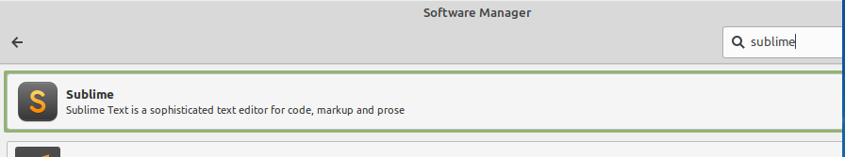

Install the GPG key:
wget -qO - https://download.sublimetext.com/sublimehq-pub.gpg | sudo apt-key add -

Ensure apt is set up to work with https sources:
sudo apt-get install apt-transport-https

Select the channel to use:

Stable
echo "deb https://download.sublimetext.com/ apt/stable/" | sudo tee /etc/apt/sources.list.d/sublime-text.list

Dev
echo "deb https://download.sublimetext.com/ apt/dev/" | sudo tee /etc/apt/sources.list.d/sublime-text.list

Update apt sources and install Sublime Text
sudo apt-get update
sudo apt-get install sublime-text

Install PIP3

Pip
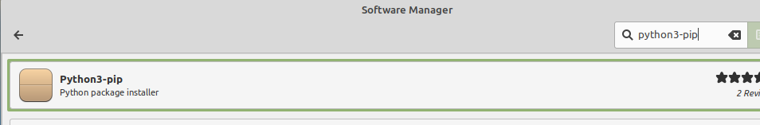
sudo apt-get install python3-pip -y

Examples

Cloudflare


Testresources

Install Libtorrent

Future

SQLite Browser


Cloudscraper
pip3 install -U cloudscraper

Subliminal
Required to download subtitles
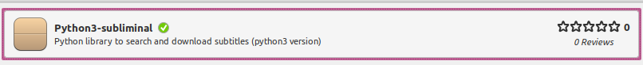
Sudo pip3 install subliminal
Fix 234 remove indent
Line /usr/local/lib/python3.8/dist-packages/subliminal/providers/addic7ed.py
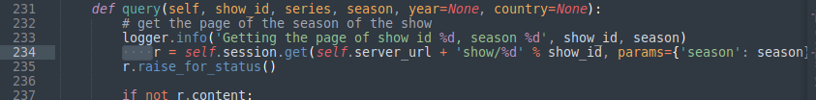

Install from Snap Store

Enable snaps on Linux Mint and install Subliminal Subtitles
Snaps are applications packaged with all their dependencies to run on all popular Linux distributions from a single build. They update automatically and roll back gracefully.
Snaps are discoverable and installable from the Snap Store, an app store with an audience of millions.

Enable snapd
Snap is available for Linux Mint 18.2 (Sonya), Linux Mint 18.3 (Sylvia), Linux Mint 19 (Tara), Linux Mint 19.1 (Tessa) and the latest release, Linux Mint 20 (Ulyana). You can find out which version of Linux Mint you’re running by opening System info from the Preferences menu.
On Linux Mint 20, /etc/apt/preferences.d/nosnap.pref needs to be removed before Snap can be installed. This can be accomplished from the command line:
sudo rm /etc/apt/preferences.d/nosnap.pref
sudo apt update
To install snap from the Software Manager application, search for snapd and click Install.
Alternatively, snapd can be installed from the command line:
sudo apt update
sudo apt install snapd
Either restart your machine, or log out and in again, to complete the installation.

Install Subliminal Subtitles
To install Subliminal Subtitles, simply use the following command:
sudo snap install subliminal-subtitles

Git & Github installation

Install GIT
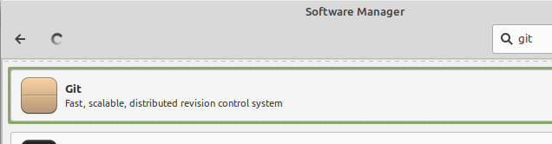

GITHUB

Debian/Ubuntu distributions
To setup the package repository, run these commands:
wget -qO - https://packagecloud.io/shiftkey/desktop/gpgkey | sudo tee /etc/apt/trusted.gpg.d/shiftkey-desktop.asc > /dev/null
sudo sh -c 'echo "deb [arch=amd64] https://packagecloud.io/shiftkey/desktop/any/ any main" > /etc/apt/sources.list.d/packagecloud-shiftky-desktop.list'
sudo apt-get update
Then install GitHub Desktop:
sudo apt install github-desktop

Debian/Ubuntu distributions
Or, You can directly download the .deb package from the archlinux AUR https://aur.archlinux.org/packages/github-desktop-bin
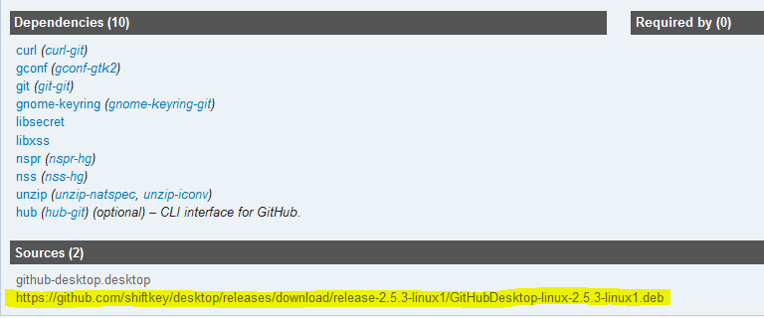
sudo wget https://github.com/shiftkey/desktop/releases/download/release-2.6.3-linux1/GitHubDesktop-linux-2.6.3-linux1.deb

Screenshots [ Github Desktop running on Linux Mint ]
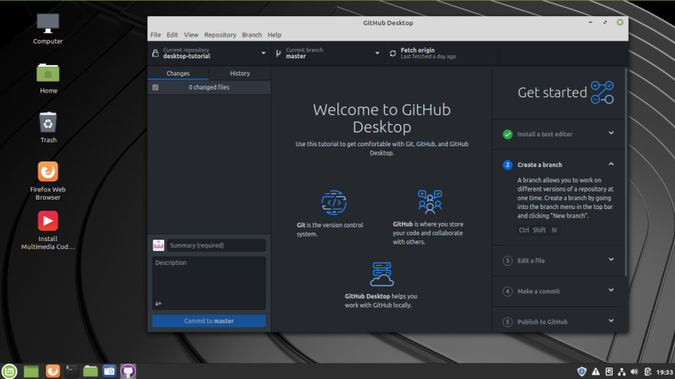
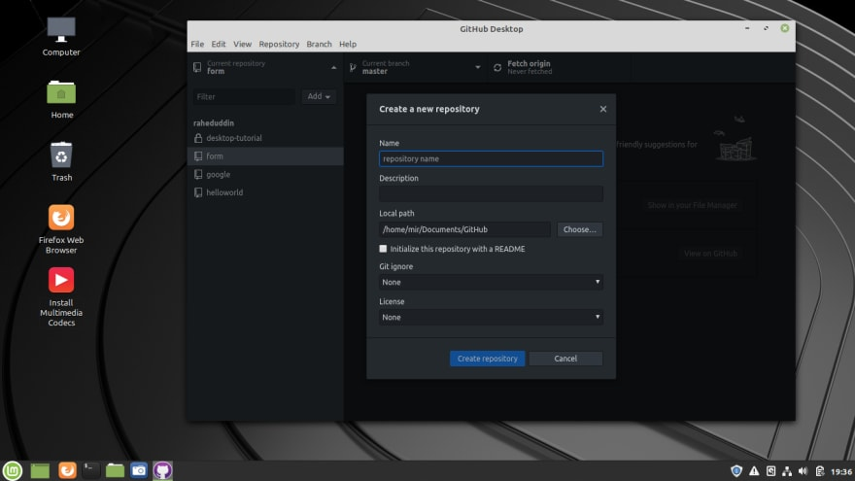
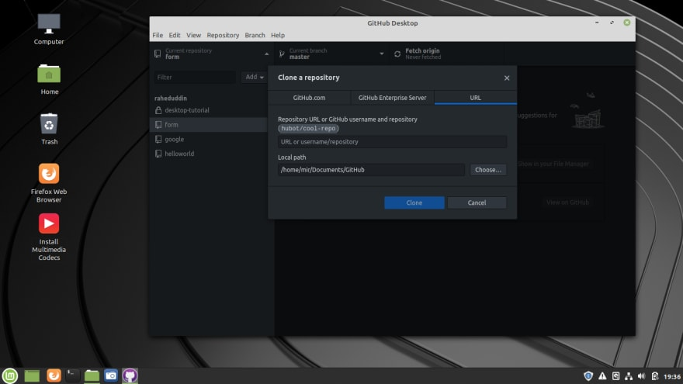

Flexget

Install Flexget

In Virtual Enviroment

Create virtualenv
Python virtualenvs provide isolated python runtime. It does not mess with your operating system and can be easily deleted and recreated if needed.
python3 -m venv ~/flexget/

Install Flexget
cd ~/flexget/
bin/pip install flexget
This will install FlexGet and all of it’s dependencies.

Running FlexGet from the virtualenv
The virtualenv can be activated with this command:
source ~/flexget/bin/activate
After activation, the command flexget will work from anywhere. Note that activation does not persist over to new shell sessions.
Alternatively you can use following command without activating virtualenv.
~/flexget/bin/flexget [options]
You will need to use this form if you use crontab to schedule FlexGet executions.

Not in VirtualEnv
sudo pip3 install flexget
sudo pip3 install --upgrade flexget
This will install FlexGet and all of it’s dependencies.

Flexget Scheduler

Daemon Mode

Cron
Probably easiest and most compatible if used virtualenv.
crontab -e
put
@reboot /usr/local/bin/flexget daemon start -d --autoreload-config

Usage
To launch the FlexGet daemon, use the start command:
- Note: Using the optional -d switch will send the FlexGet daemon to the background. Using --autoreload-config will force config reloads before task execution.^
- Note 2: In earlier versions, use --config-autoreload instead of --autoreload-config^
flexget daemon start -d, --autoreload-config
To stop a currently running daemon you can use stop:
flexget daemon stop
To check the status of the flexget daemon you can use status:
flexget daemon status
To have the daemon reload the config file from disk you can use the reload-config command:
flexget daemon reload-config

Transmission

Add repository

Add Transmission Repository
sudo add-apt-repository ppa:transmissionbt

Update Repository
sudo apt update

Install Transmission

Transmission
Now, issue the following command to install Transmission
sudo apt install transmission
Not install
sudo apt-get install transmission-gtk transmission-cli transmission-common transmission-daemon

Step 5: Verify Installation
Once the Transmission application has been installed successfully, execute the following command to verify the installation:
transmission-gtk --version
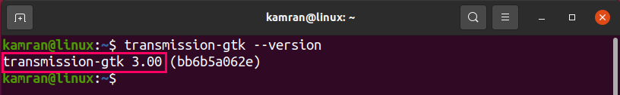
sudo apt-get install transmission-gtk transmission-cli transmission-common transmission-daemon
The output confirms that Transmission 3.00 has been installed successfully on my system.

Transmission-RPC
pip install transmission-rpc -U

Transmission-deamon
sudo apt-get install transmission-daemon

Launch and Use Transmission
The Transmission application can be launched either from the terminal or the Applications menu. To launch Transmission from the Applications menu, open the Applications menu, and search for the Transmission application in the search bar.
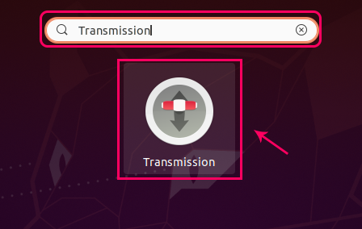
To launch the Transmission application from the terminal, issue the following command:
transmission-gtk
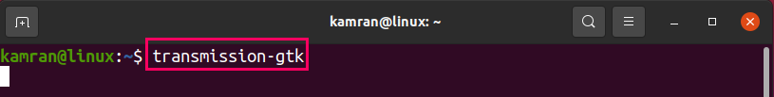
Upon the first launch, the Transmission application will display a window with the Terms and Conditions. Click I Agree to agree to the Terms and Conditions.
Next, Transmission’s dashboard screen will appear.
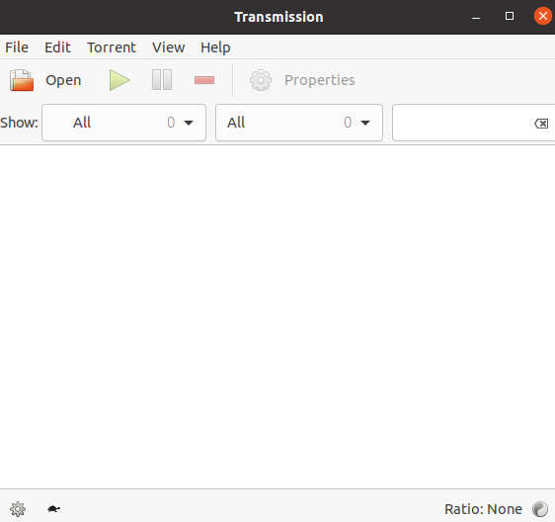
To open a torrent file, click Open and select the file.
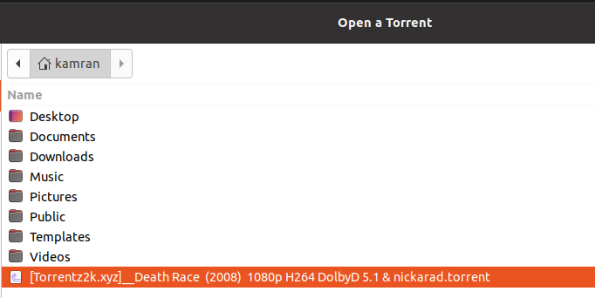
Select the destination folder and torrent priority, then click Open.
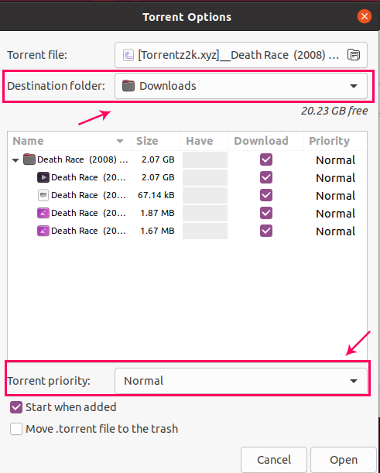
The Transmission application will now begin downloading the data.
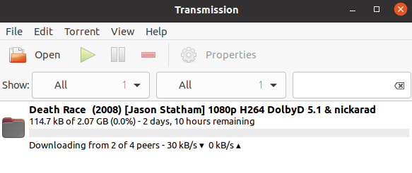

Configure deamon
There are many settings which can be configured. This how-to focus on tweaking the default configuration file for use with Ubuntu server.
transmission-daemon will start automatically each time you start your server, with the settings defined in /var/lib/transmission-daemon/info/settings.json
Make sure the Transmission daemon is not running when changing the config file otherwise your changes will be over written.
sudo service transmission-daemon stop
edit /var/lib/transmission-daemon/info/settings.json
sudo nano /var/lib/transmission-daemon/info/settings.json

Username and Password
The default rpc-username and password is “transmission”
Change if increased security is required
Change it to whatever you want (any password will work). After next restart the password will be rewritten in SHA1 encrypted format for security reasons.
"rpc-password": "{62b16db87b89a91dd49a5110a7cafc06d20eb4f2wtK6kqPj",
"rpc-username": "transmission",

Whitelist
This must be changed for remote access
rpc-whitelist defines access to transmission. Localhost (127.0.0.1) is defined by default. I added ,192.268.*.* to allow any machine on my LAN access.
"rpc-whitelist": "127.0.0.1,192.168.*.*",

"umask" parameter
You will also have to set the "umask" parameter in Transmission’s settings file to “2” (default is 18) for the account user to have full access to files/folders created by Transmission.
"umask": 2,

Default File Directory
Place a torrent file in this directory for automatic file download
/var/lib/transmission-daemon/downloads/

Configure Users and Permissions
It is recommended that Transmission runs under it’s own username for security reasons. This creates a few issues with file and folder access by Transmission as well as your account (let us assume it is user).
Add the username user to the group debian-transmission:
sudo usermod -a -G debian-transmission user
NOTE: Change "user" to you own Ubuntu user login name.
NOTE: When adding a user to a new group, the user must log out and log back in for it to take affect. A reboot will also accomplish this.

Starting and Stopping Transmission Daemon
After install Transmission, the daemon will be started automatically (but not accessible yet). You can start and stop Transmission daemon using the following commands
sudo service transmission-daemon start
sudo service transmission-daemon stop
sudo service transmission-daemon reload
sudo service transmission-daemon start
Note:Restarting (or reloading) Transmission daemon can be tricky. Restarting the the daemon (while it is already running) would rewrite the Transmission settings files to its original state. In other words, restarting the Transmission daemon would reset all the custom settings you saved.

Errors
Open this text file as root, be aware it is one of those important system files:
Sudo nano /etc/sysctl.conf
I added these two lines since I have enough memory; if you are for instance on an embedded system, you might want to re-consider applying these lines (we're setting 16 MiB for the receive buffer and 4 MiB for send buffer), I can't tell the actual running memory requirements yet:
net.core.rmem_max = 1048576
net.core.wmem_max = 4194304
If you decided to add those lines above, you can re-read the config with:
sudo sysctl -p
There is no need for a reboot to take effect.

Bash Aliases
Create shortcuts add the following bash aliases to /home/user/.bash_aliases
sudo nano /home/user/.bash_aliases
alias t-start='sudo service transmission-daemon start'
alias t-stop='sudo service transmission-daemon stop'
alias t-reload='sudo service transmission-daemon reload'
alias t-list='transmission-remote -n 'transmission:transmission' -l'
alias t-basicstats='transmission-remote -n 'transmission:transmission' -st'
alias t-fullstats='transmission-remote -n 'transmission:transmission' -si'
source /home/user/.bash_aliases
Example
user@SVR:~$ t-list
will run
transmission-remote -n 'transmission:transmission' -l

Web Interface
With your browser you can now add torrents, download and seed. You can also configure many transmission settings.
http://server-ip:9091

Port Forward
There are many options but one of the more important one's is port forwarding
Check your ports are open

Edit
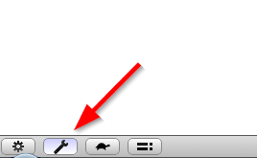

Port Forward
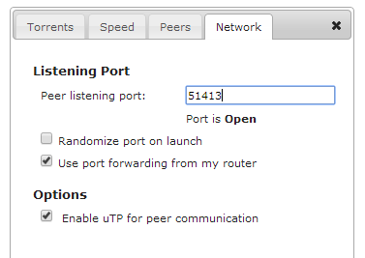
If you port says "closed" you will need to configure your internet router to forward the correct port to your Transmission server/client. Google "How to port forward"
If you don't use "Port Forward" another option is "UPnP". Once again this depends on you internet router setup.

Deluge

Install Deluge

GUI install from Terminal:
sudo apt-get install deluge
Headless install from Terminal:
sudo apt-get install deluged
sudo apt-get install deluge-web
sudo apt-get install deluge-console
Although Deluge is included in the official ​Ubuntu repositories it may be out of date. To ensure you are using the latest version use the PPA Repository, see the steps below.
Deluge PPA Repository

The ​Deluge PPA contains the latest Deluge releases for Ubuntu.

sudo add-apt-repository ppa:deluge-team/stable
sudo apt-get update
sudo apt-get install deluge
sudo apt-get install deluge-console
sudo apt-get install deluged
sudo apt-get install deluge-web
sudo pip3 install deluge-client

Removing
sudo apt-get remove deluge

Deluge Service

Create a service specific user

For security it is best to run a service with a specific user and group. You can create one using the following command:
sudo adduser --system --gecos "Deluge Service" --disabled-password --group --home /var/lib/deluge deluge
This creates a new system user and group named deluge with no login access and home directory /var/lib/deluge which will be the default location for the config files.

In addition you can add to the deluge group any users you wish to be able to easily manage or access files downloaded by Deluge, for example:
sudo adduser deluge deluge
sudo adduser gert deluge

Daemon (deluged) service
Create the file /etc/systemd/system/deluged.service containing the following:
sudo nano /etc/systemd/system/deluged.service
[Unit]
Description=Deluge Bittorrent Client Daemon
Documentation=man:deluged
After=network-online.target

[Service]
Type=simple
UMask=007

ExecStart=/usr/bin/deluged -d

Restart=on-failure

# Time to wait before forcefully stopped.
TimeoutStopSec=300

[Install]
WantedBy=multi-user.target

User configuration
To run the service using the previously created user e.g. deluge, first create the service configuration directory:
sudo mkdir /etc/systemd/system/deluged.service.d/
Then create a user file /etc/systemd/system/deluged.service.d/user.conf with the following contents:
sudo nano /etc/systemd/system/deluged.service.d/user.conf
# Override service user
[Service]
User=deluge
Group=deluge

Start deluged service
Now enable it to start up on boot, start the service and verify it is running:
sudo systemctl enable /etc/systemd/system/deluged.service
sudo systemctl start deluged
sudo systemctl status deluged

Umask for deluged downloaded files

The umask in the service file can be modified to determine access to files downloaded by deluged (also applies to logging files). Some useful access values are detailed as follows:

000 - full access for all users and groups.
007 - only user and group that deluged is running as (e.g. deluge) with no access from any other accounts.
002 - user and group deluged is running as with read-only for all other accounts.
022 - user deluged is running as with read-only for all other accounts.

The service for deluged must be stopped and started instead of just restarted after changes.

Web UI (deluge-web) service

Create the file /etc/systemd/system/deluge-web.service containing the following:
sudo nano /etc/systemd/system/deluge-web.service
[Unit]
Description=Deluge Bittorrent Client Web Interface
Documentation=man:deluge-web
After=network-online.target deluged.service
Wants=deluged.service

[Service]
Type=simple
UMask=027

ExecStart=/usr/bin/deluge-web -d

Restart=on-failure

[Install]
WantedBy=multi-user.target

User configuration

To run the service using the previously created user e.g. deluge, first create the service configuration directory:
sudo mkdir /etc/systemd/system/deluge-web.service.d/
Then create a user file /etc/systemd/system/deluge-web.service.d/user.conf with the following contents:
sudo nano /etc/systemd/system/deluge-web.service.d/user.conf
# Override service user
[Service]
User=deluge
Group=deluge

Start deluge-web service
Now enable it to start up on boot, start the service and verify it is running:
sudo systemctl enable /etc/systemd/system/deluge-web.service
sudo systemctl start deluge-web
sudo systemctl status deluge-web
Fix NGETTEXT error:
edit: /usr/lib/python3/dist-packages/deluge/i18n/util.py
Line 117 update to “gettext.install(I18N_DOMAIN, translations_path, names=['ngettext'], **kwargs)”

How do I auto-connect to a specific daemon?

- Stop the Web UI before modifying the web.conf file.
- Edit web.conf in config, find "default_daemon" and set its value to the daemon id in hostlist.conf
e.g. To connect to localhost you would open hostlist.conf as see a snippet such as:
"123459d5a5b414159caa1323f6e0c9b240c7abcd",
"localhost",
58846,
- Use the first entry from hostlist, which is the id and add it to web.conf:
"default_daemon": "123459d5a5b414159caa1323f6e0c9b240c7abcd",

Restart the Web UI.

Service logging

Create a log directory for Deluge and give the service user (e.g. deluge), full access:

sudo mkdir -p /var/log/deluge
sudo chown -R deluge:deluge /var/log/deluge
sudo chmod -R 750 /var/log/deluge

The deluge log directory is now configured so that user deluge has full access, group deluge read only and everyone else denied access. The umask specified in the services sets the permission of new log files.

Enable logging in the service files by editing the ExecStart line, appending -l and -L options:

ExecStart=/usr/bin/deluged -d -l /var/log/deluge/daemon.log -L warning
ExecStart=/usr/bin/deluge-web -d -l /var/log/deluge/web.log -L warning

See deluged -h for all available log-levels.

Restart the services:

sudo systemctl daemon-reload
sudo systemctl restart deluged
sudo systemctl restart deluge-web

Log rotation

To enable log rotation append --logrotate to the above ExecStart lines.
Conditionally start deluged for mount points

If you have a USB disk drive or network drive that may not be immediately available on boot or disconnected at random then you may want the deluged service to wait for mount point to be ready before starting. If they are unmounted or disconnected then deluged is stopped. When they become available again deluged is started.

Ensure you have added the correct drive details to fstab or equivalent so they are mounted at boot.

List the available drive mounts:

sudo systemctl -t mount

Look for your mount point in the Description column. Mounts are formatted similar to the mount point with -s replacing /s in the path. e.g.: media-xyz.mount

Modify the [Unit] section of the deluged.service script by adding the details below, substituting xyz.mount for the mount you want the service to depend on:

[Unit]
Description=Deluge Bittorrent Client Daemon
# Start after network and specified mounts are available.
After=network-online.target xyz.mount
Requires=xyz.mount
# Stops deluged if mount points disconnect
BindsTo=xyz.mount

For multiple mount points add a space between additional entries. e.g.:

After=network-online.target xyz.mount abc.mount def.mount

Modify the [Install] section to ensure the deluged service is started when the mount point comes back online:

[Install]
WantedBy=multi-user.target xyz.mount

Thin Client

Deluge Daemon Setup

The Deluge daemon deluged and deluge-console should be installed on the server.

See the service guides to run deluged as a service so that it starts/stops on server boot/shutdown. Substitute any daemon start or stop commands below with the appropriate service commands.

To debug any problems setting up deluged enable logging and check for errors.

Create Default Config

To create the config directory and populate with the default files, run and then stop deluged. (If using a service substitute appropriate operating system commands):

deluged
killall deluged

Note: The config location is either the default location with reference to the user that deluged is running as. Alternatively if using a service it will be specified in the service config files with -c <path> option.

Add User to the authentication file

Create a Deluge user for clients/UIs to access the daemon by editing the authentication file, auth, located in the above config location.

The auth file should consist of lines of <username>:<password>:<level>. Replace <username> and <password> with your choice and <level> with the desired authentication level.

You can use your favourite text editor to achieve this or can be done with a one-line echo command e.g.:

echo "alice:MyC0mpL3xPass:10" >> ~/.config/deluge/auth

Enable Remote Connection

We will use deluge-console to configure deluged to accept connections from computers other than localhost. For SSH Tunnelling you do not need to enable remote connections so this step can be skipped.

Using the Console in command-line mode, set the allow_remote option and then verify with these commands:

deluge-console "config -s allow_remote True"
deluge-console "config allow_remote"

If you are running deluged under another user (e.g. deluge) you will need to temporarily login as that user to enable deluge-console to access that daemon's config:

su --shell /bin/bash --login deluge

Alternatively you can edit core.conf (deluged must not be running) in the config and change allow_remote from false to true.

Start Deluge Daemon

deluged

Verify Server IP Address

You will need to know the server's IP address for configuring clients, for private IP: hostname -I or public IP: curl ifconfig.me

Congratulations! The server is now setup for remote client access.

Client Setup

Accessing deluged service with local UI Client

When attempting to access a daemon deluged on the same machine but running as a different user e.g. your login user is user and deluged is running as deluge, you may be unable access to deluged. This is due to the client automatically authorising using the localhost line in the auth file, which is assumed to be at the same config location as deluged.

The workaround is to replace the localclient line in your user config auth file (~/.config/deluge/auth) with the localclient line from the deluged config auth file e.g. /var/lib/deluge/auth.

GTK UI

The Deluge GTK UI setup require switching the GTK UI from Classic mode to Thin-client mode, then adding and connecting to the remote daemon on the server.

- In Preferences -> Interface and disable (untick) Classic Mode
- Restart deluge and you should see the Connection Manager.
  - If it is not needed you can remove the localhost daemon.
  - If SSH Tunnelling, before continuing Create SSH Tunnel, and for Hostname, below, 127.0.0.2 must be used.
- Create a new entry with Add button:
  - Hostname is your server's IP.
  - Port should be default 58846.
  - Username and Password are those added to the deluged config auth file.

If this was successful a green tick should now appear as the status for the daemon you just added.

Click on Connect and the Connection Manager should disappear.

Optional step: Expand Options and select 'Automatically connect to selected host on startup' and 'Do not show this dialog on start-up'.

Congratulations! You can now access the Deluge daemon, deluged, on the server via the GTK UI.

Console

If accessing a local deluged daemon run the following and it will connect automatically:

deluge-console

To connect to a remote daemon use the connect command in deluge-console:

connect <host>[:<port>] <user> <password>

or from the terminal:

deluge-console "connect <host>[:<port>] <user> <password>"

For adding torrents directly to the daemon through automatic methods such as with autodl-irssi:

deluge-console "connect <host>[:<port>] <user> <password> ; add $(TorrentPathName) ; exit"

Web UI

The Web UI is slightly different as the client is a web server daemon deluge-web that connects to a running deluged.

Install deluge-web and run it:

deluge-web

Note: To run it in the background as a daemon, use --fork option. You may also want to set it up as a service.

In your web browser, enter the url below where <server> is the IP address of the server:

http://<server>:8112

Default password is: deluge

Congratulations! You can now access deluge on the server via the Web UI.

Create SSH Tunnel

From Deluge 1.2 onward, all communication between the GTK UI and daemon is encrypted using a automatically generated self-signed certificate so SSH tunneling is not a requirement if you are on a trusted local network. If you access the daemon over the internet, you should still use a SSH tunnel.

In a Terminal, enter the following, replacing <server> with the public IP of your server.

ssh -fNL 127.0.0.2:58846:localhost:58846 <server>

Note: We use 127.0.0.2 instead of localhost so that Deluge client knows that we are connecting to a remote daemon. Otherwise you will encounter problems with file browsing as it will assume to be on local client machine rather than remote server.

If you get the error 'bind: Can't assign requested address', you need to add 127.0.0.2 as an alias for the loopback device:

sudo ifconfig lo0 add 127.0.0.2

Deluge [Plugin] Auto Remove Plus v0.6.1
https://forum.deluge-torrent.org/viewtopic.php?t=47243
Deluge: Modify AutoRemovePlus Plugin to delete dead torrents based on Availability – Tricksty

Deluge: Modify AutoRemovePlus Plugin to delete dead torrents based on Availability
BY ABIR · JUNE 20, 2020
Deluge has this great plugin AutoRemovePlus:
https://github.com/omaralvarez/deluge-autoremoveplus

It can remove torrents based on certain conditions:
– Remove by ratio, seed time, date added, seeders.
It only works if a torrent is completed. Also, it will remove based on a ‘Minimum’ condition.
e.g. remove torrent if it has minimum x seeds: means remove all torrents with more than x seeds.
Sometimes some torrents are dead and there are no longer any seeds available.
‘Availability’ means how many actual copies of the torrent exist.
Even if you can’t find seeders at a certain time but if availability is more than 1 means eventually the torrent will complete because seeders do exist.
So, suppose we need to be able to remove torrents with availability lower than say 0.8 and for date added more than 5 days. This will remove all dead torrents – torrents which have’t got any copies for 5 days.
This post will give you a step by step guide to modify the Deluge plugin AutoRemovePlus to add this feature.
I am using Ubuntu 12.04 running on KDE and Deluge 1.3.15.
And at the end of post is a download link with the modified plugin.
All modified code is between comments: #ABIROID MOD and #ABIROID MOD END
At the time of writing this post the latest AutoRemovePlus version is: AutoRemovePlus-0.6.1-py2.7.egg

UNZIP and ZIP:
If by the time you are reading the post, a new plugin is available then just get a fresh copy from github.
– .egg file is just a zip file renamed to egg.
– Unzip the egg file to any folder:
unzip AutoRemovePlus-0.6.1-py2.7.egg -d myautoremovedir
– Go to myautoremovedir and you’ll see 2 folders:
autoremoveplus and EGG-INFO
– We will be making changes to files inside autoremoveplus folder then we’ll zip the file and replace the original egg file like so:
zip -r AutoRemovePlus-0.6.1-py2.7.egg autoremoveplus EGG-INFO/
mv AutoRemovePlus-0.6.1-py2.7.egg ~/.config/deluge/plugins/
Note that everytime you make any changes to plugin, you’ll need to restart Deluge.
Just Ctrl+Q (exit) in deluge and re-run it. Should be very quick.

Understanding the File Structure:
– autoremoveplus/core.py file contains the main functionality.
– autoremoveplus/ –> gtkui.py and webui.py files contain how the plugin will look in the deluge app and the web page.
– The Desktop app look is based in: data/config.glade and the WebUI look is based in: data/autoremoveplus.js

Making Changes:
Firstly open core.py.
‘filter_funcs’ contains all the remove rules like: remove based on ratio, date added, seed time, etc.
These are all lambda functions. Here we need to add a rule for availability.
In libtorrent availability is denoted by the variable: ‘distributed_copies’
– So add this line to the end of ‘filter_funcs’:
'func_availability': lambda (i, t): t.get_status(['distributed_copies'])['distributed_copies']
If any confusion please refer to line 90 in the code files (bottom of this post).
– Next, inside def get_remove_rules(self): add this:
'func_availability': 'Availability'
(Line: 159)
– If you want to be able to remove incomplete torrents as well then comment these lines of code:
#try:
# finished = t.is_finished
#except:
# continue
#else:
# if not finished:
# continue
(Line 303)
The above piece of code checks if torrent is finished, and only then run the remove functions. Commenting it will prevent the check.
– Then find this part of code:
filter_1 = filter_funcs.get(
self.config['filter'],
_get_ratio
)((i, t)) >= min_val
# Get result of second condition test
filter_2 = filter_funcs.get(
self.config['filter2'], _get_ratio
)((i, t)) >= min_val2
Here filter 1 and 2 both check for values ‘Greater than’ MIN specified values.
Like remove torrent of seeders more than MIN
Or
Remove torrents if Date Added more than MIN.
For date added this is fine. But for Availability, we need it to remove if Availability ‘Less than’ MIN.
Or for seeders less than MIN.
So, just change the condition for filter 1 to <=
– Now since we have changed the condition, we also need to change the labels in GUI so that it is not confusing.
Open config.glade and find the text ‘Min:’
You’ll find it at 2 places. At first place change Min: text to ‘Remove Less than:’
And at second place change text ‘Min:’ to ‘Remove More than:’
So it should look like:

True
False
True
Minimum age and seed time is measured in days
Remove Less than:

– Also, go to autoremoveplus.js file and find same text ‘Min:’. Once again it will be at 2 places and make a similar change and code should look like:
xtype: 'spinnerfield',
//anchor: '20%',
//margins: '0 0 0 0',
name: 'min',
fieldLabel: _('Remove Less than'),
value: 0.0,
maxValue: 10000.0,
minValue: 0.0,
allowDecimals: true,
decimalPrecision: 3,
incrementValue: 0.5,
alternateIncrementValue: 1.0,
flex: 0.35
– In core.py you can also add some debug/warning statements to check the values for torrents being removed or paused:
Find code with ‘remove_cond’ and add log statements:
if remove_cond:
if not remove:
self.pause_torrent(t)
log.warn(
"AutoRemovePlus: Pause torrent %s, %s, %s, %.3f"
% (i, t.get_status(['name'])['name'], t.get_status(['distributed_copies'])['distributed_copies'], (time.time() - t.time_added) / 86400.0)
)
else:
if self.remove_torrent(torrentmanager, i, remove_data):
changed = True
log.warn(
"AutoRemovePlus: Delete torrent %s, %s, %s, %.3f"
% (i, t.get_status(['name'])['name'], t.get_status(['distributed_copies'])['distributed_copies'], (time.time() - t.time_added) / 86400.0)
)
You can add log.debug if you want to keep these as debug statements. I prefer log.warn.
Running deluge with debug creates a lot of logs and we just need to check our autoremoveplus plugin logs.
Now that all changes are done, just zip up the file as shown in the above UNZIP and ZIP section.
And run deluge from command line like so:
deluge -L warning -l /var/log/deluge.log
Open up another terminal and tail the logs like so:
tail -f /var/log/deluge.log | grep -i autoremove
– Go to deluge and set your settings something similar to:
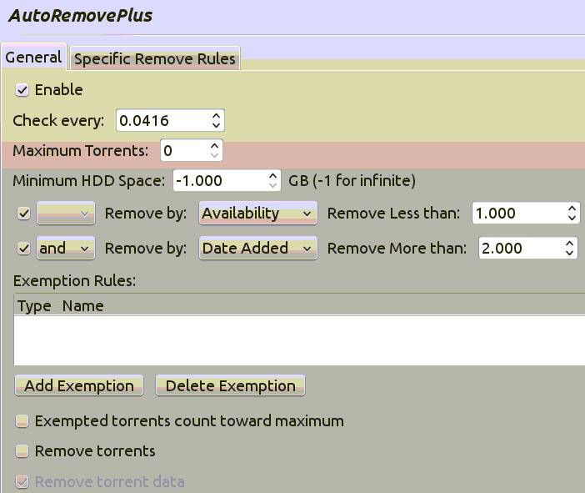
At first make sure that the ‘Remove Torrent’ checkbox is unchecked, so that it will only pause your torrents.
Then, whenever you click apply the plugin will run. Make sure to look at the debug values in the tailed logs.
Once you are sure it’s absolutely working, only then check the ‘Remove Torrent’ and ‘Remove Torrent Data’ checkbox.
Here’s the link to the modified egg file:
tricksty.com_AutoRemovePlus-0.6.1-py2.7.zip (59 downloads)
Usage:
– Rename abiroid.com_AutoRemovePlus-0.6.1-py2.7.zip to AutoRemovePlus-0.6.1-py2.7.egg
– Copy to your deluge plugins directory:
~/.config/deluge/plugins/

https://forum.deluge-torrent.org/viewtopic.php?f=9&t=55733

Executable script
# Upgrade system
sudo apt update && sudo apt upgrade -y

# python
sudo add-apt-repository ppa:deadsnakes/ppa -y
sudo apt update
sudo apt install python3.11

# Sublime
wget -qO - https://download.sublimetext.com/sublimehq-pub.gpg | sudo apt-key add -
sudo apt-get install apt-transport-https
echo "deb https://download.sublimetext.com/ apt/stable/" | sudo tee /etc/apt/sources.list.d/sublime-text.list
sudo apt-get update
sudo apt-get install sublime-text

#PIP
sudo apt-get install python3-pip -y
#Examples
sudo apt-get install -y python3-examples
#Future
sudo apt-get install -y python3-future
#Test Resources
sudo apt-get install -y python3-testresources
#Cloudflare
sudo apt install python3-cloudflare
#Libtorrent
sudo apt install python3-libtorrent

#Cloudscraper
pip3 install -U cloudscraper

#Github
wget -qO - https://packagecloud.io/shiftkey/desktop/gpgkey | sudo tee /etc/apt/trusted.gpg.d/shiftkey-desktop.asc > /dev/null
sudo sh -c 'echo "deb [arch=amd64] https://packagecloud.io/shiftkey/desktop/any/ any main" > /etc/apt/sources.list.d/packagecloud-shiftky-desktop.list'
sudo apt-get update
sudo apt install github-desktop

#Flexget
sudo pip3 install flexget
sudo pip3 install --upgrade flexget

#Deluge
sudo add-apt-repository ppa:deluge-team/stable
sudo apt-get update
sudo apt-get install deluge
sudo apt-get install deluge-console
sudo apt-get install deluged
sudo apt-get install deluge-web
sudo pip3 install deluge-client

# Subliminal
sudo pip3 install subliminal

***********************************************
Add execution permissions to the downloaded install.sh script file:
sudo chmod +x install.sh
***********************************************

https://www.nakivo.com/blog/install-ubuntu-20-04-on-hyper-v-with-enhanced-session/

Index

Cloudflare, 2, 11
Cloudscraper, 2, 13
Deluge, 27, 28, 30, 31, 33, 34, 35, 36, 38, 39, 40
Install, 27
Examples, 2, 11
Flexget, 2, 18
Future, 2, 11
Git, 2, 15
GITHUB, 2, 15
Libtorrent, 2, 11
Pip, 2, 11
PIP3, 2, 11
SQLite Browser, 2, 12
Sublime, 10
Subliminal, 2, 14
Testresources, 2, 11
Transmission, 2, 3, 20, 21, 23, 24, 25, 26

https://snapcraft.io/install/subliminal-subtitles/mint

